**User Personas**

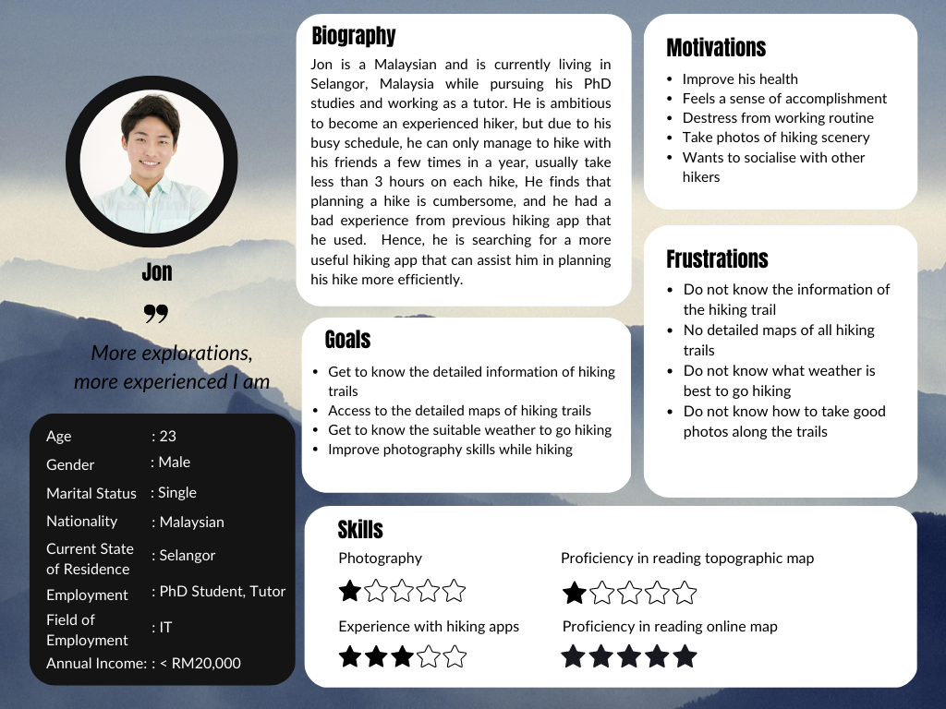

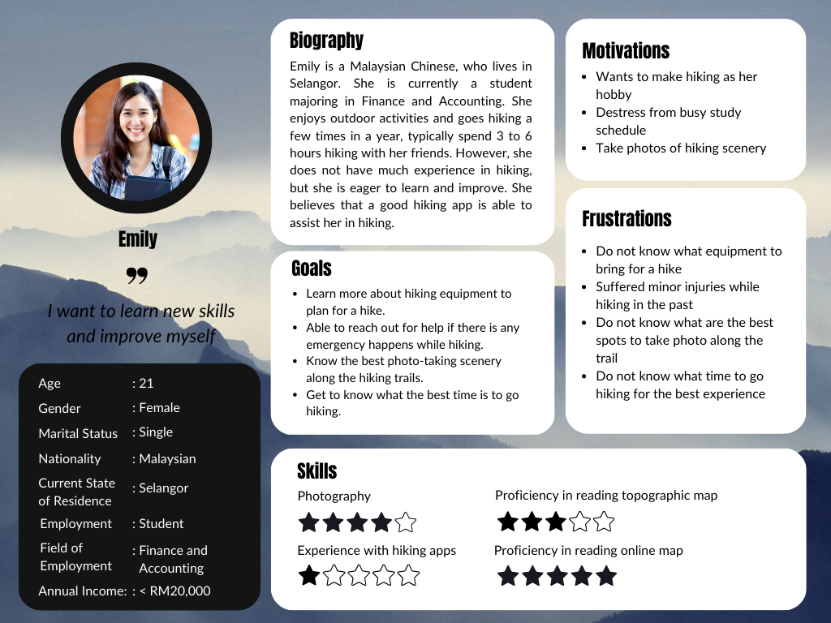

<https://www.canva.com/design/DAFdGBAllqc/mZGKOSdHN1h1CkRSZXrOjA/edit?utm_content=DAFdGBAllqc&utm_campaign=designshare&utm_medium=link2&utm_source=sharebutton>

**User Stories**

| Priority | User Stories | Justification |
| --- | --- | --- |
| Must Have | * As Jon, I want to access detailed information about each hiking trail so that I can plan my hike more efficiently. * As Emily, I want to be able to view the hiking trails on a detailed map, so that I can navigate the trail easily and avoid getting lost during the hike. * As Emily, I want to learn more about hiking equipment to plan for a hike, so that I can have the necessary gear for a safe and comfortable hiking experience. * As Jon, I want to know the suitable weather to go hiking, so that I can plan my hike accordingly and avoid hiking during bad weather conditions. | Planning a hike can be time-consuming and challenging, especially for novice hikers or those with busy schedules. However, by providing comprehensive information about hiking trails in our app, hikers can easily find and filter trails based on their preferences. Given that most hikers are beginners, they may need an easy-to-read map to guide them along the trails.  Moreover, it's crucial for hikers to know what essentials they need to bring along for their hike. To save their time and effort, they need a complete list of equipment required for each hiking trail, so they don't have to search for these items online. Additionally, being aware of weather conditions before beginning a hike is essential for the hiker's safety and enjoyment. Hence, information on current and forecasted weather conditions is essential for planning a hike.  The features above are the key aspects that can fulfil most of the users’ needs, hence they must be implemented. |
| Should Have | * As Emily, I want to have access to safety information and emergency contacts for each hiking trail, so that I can easily reach out for any emergency help during my hike. | Hiking is undoubtedly an outdoor activity that involves potential risks, such as getting lost or experiencing injuries. It is crucial for hikers to have access to safety measures during the hike, and it raises the need to have emergency features in the hiking app. However, emergency contacts are not compulsory to have in the app, as some hikers are not comfortable to reach out to someone they do not know to ask for help, instead they may prefer to contact their known contacts. |
| Could Have |  |  |
| Won’t Have |  |  |

**Additional Requirements**

**A feature that allows users to get a list of equipment they should bring for a hike.**

For beginner hikers, it can be challenging to know what equipment is necessary for a safe and comfortable hiking experience. Providing a feature that allows users to obtain a list of essential gear based on the trail difficulty level and weather conditions can help to ensure that they are properly prepared for their hike, as well as to enhance their user experience towards our app.

**A feature that would allow users to contact an offline emergency hotline**.

Safety is a significant concern among the hikers, especially for those who are new to hiking. By embedding the offline emergency hotline feature in the app, users can contact the emergency services even if they are in the area with poor or no network connection. In case of an accident or unexpected emergencies, they can use the feature that will automatically connect them to the nearest emergency service. The feature will also capture the user's GPS location, and share it with the emergency hotline operator. This can help the operator to locate the user and provide assistance as quickly as possible.

**Individual Analysis/Reflection**

After analysing the survey data, I have created two user personas, named Jon and Emily. These personas enable us to understand the motivations and frustrations of our users associated with their goals. By crafting user stories tailored to our personas, we can effectively explain how and why they would engage with our app. This approach helps us avoid the need to constantly refer to the raw survey data, allowing us to maintain a more streamlined and focused scope.

Jon is a 23-year-old male PhD student who is studying Information Technology, working as a part-time tutor during his spare time. He represents a group of enthusiastic but relatively inexperienced hikers who have used hiking apps and are now looking for a more efficient and useful hiking app to assist them in planning their hikes. I selected Jon's characteristics based on the largest group of users from our collected survey responses. The age group(18-35) is 88.4%, gender(male) is 58.9%, nationality(Malaysia) is 95.5%, ethnicity(Chinese) is 89.3%, and students who are studying Information Technology(IT) are 18.4%. Among the respondents from our survey who had experienced hiking apps and are keen to improve hiking skills, 68.75% of them are male. Jon likes hiking because he feels a sense of accomplishment after completing the trail. He is also ambitious to become an experienced hiker, however due to his busy schedule and the cumbersome process of planning a hike, he is restricted from going hiking frequently. He finds it difficult to get detailed information on all the hiking trails, such as the trail difficulty level, the trail location and distance, etc. For Jon, the most critical aspect of planning a hike is having access to detailed trail information. This can be seen from the data, as the majority of the survey respondents significantly ranked the importance of trail difficulty level, trail location, trail distance, trail amenities and trail reviews as either 3, 4 or 5 out of 5. Aside from that, Jon has experience in using hiking apps, and he is frustrated that the app does not provide detailed maps for all hiking trails, making it hard for him to navigate the trail as someone who is not familiar with the trail terrain. Furthermore, he prefers online maps instead of topographic maps due to his proficiency in reading the maps. The survey data shows that the majority of them, in which 80.4% of the targeted group ranked their capability to read a topographic map as either 1, 2 or 3 out of 5, whereas 94.6% of them ranked their capability to read an online map 3, 4, or 5 out of 5. To ensure his safety and the best possible hiking experience, he also wants to know the suitable weather conditions and avoid unfavourable weather. To cater to his needs, our app provides features for him to find the hiking trails based on his preferences, gain access to the detailed map, and get an updated weather forecast during his hike planning.

Emily, on the other hand, is a 21-year-old female undergraduate student who is studying Finance and Accounting. She represents a group of beginner hikers who do not have much experience in hiking, but are eager to learn and make hiking as a hobby. She enjoys outdoor activities and likes to take photos of nature along the hiking trails, which motivate her to go hiking. However, she only knows a little knowledge about hiking, for example she does not know what equipment to bring for a hike, and what is the best trail to choose according to her need. Among the respondents, 45.2% of them respond that one of the challenges they face when planning a hike is uncertainty about what gear is necessary for the hike. This makes sense since beginner hikers may not have experience in knowing what essentials to bring or leave behind. Emily also experienced injuries in her hiking before, hence she wants to be able to reach out for help if there is an emergency happen during hiking. This is inspired from the analysis that 30.9% of the respondents suffered from injuries in their previous hiking experience. To make sure the safety of hikers is protected, our app provides a feature that allows hikers to contact an offline emergency hotline, allowing hikers to easily call for assistance in case of emergency.